**Students’ Feedback Report 2020-2021**

We are collecting feedback from our students on regular basis. We have designed a special form (online) for collecting the feedback and the same is available on the college website and also on student WhatsApp groups. We are collecting feedback from students on Curriculum/Syllabus/ teaching learning process/Library/ICT facilities/ Sports/co-curricular activities/Placement Cell/Infrastructure and online classes. It is the tradition of the college to involve students in its activities. Students’ feedback is an important source of information for betterment and development of the institution.

**Feedback analysis**

**1. Opinion regarding Curriculum**

**2. Percentage of Syllabus covered in the class**

**3. How well did the teachers prepare for the classes?**

**4. How well were the teachers able to communicate?**

**5. Fairness of the internal evaluation process by the teachers.**

**6. Teachers inform you about your expected competencies, course outcomes and Programme outcomes.**

**7. Your mentor does a necessary follow-up with an assigned task to you.**

**8. Teachers are able to identify your weaknesses and help you to overcome them.**

**9. Efforts are made by the college / teachers to inculcate soft skills, life skills and employability skills to make you ready for the world of work**

**10. Use of Teaching Aids and ICT in the Class to Facilitate Teaching**

**11. Your opinion about Student - Teacher Interaction in the College.**

**Section B:**

**12. Infrastructure**

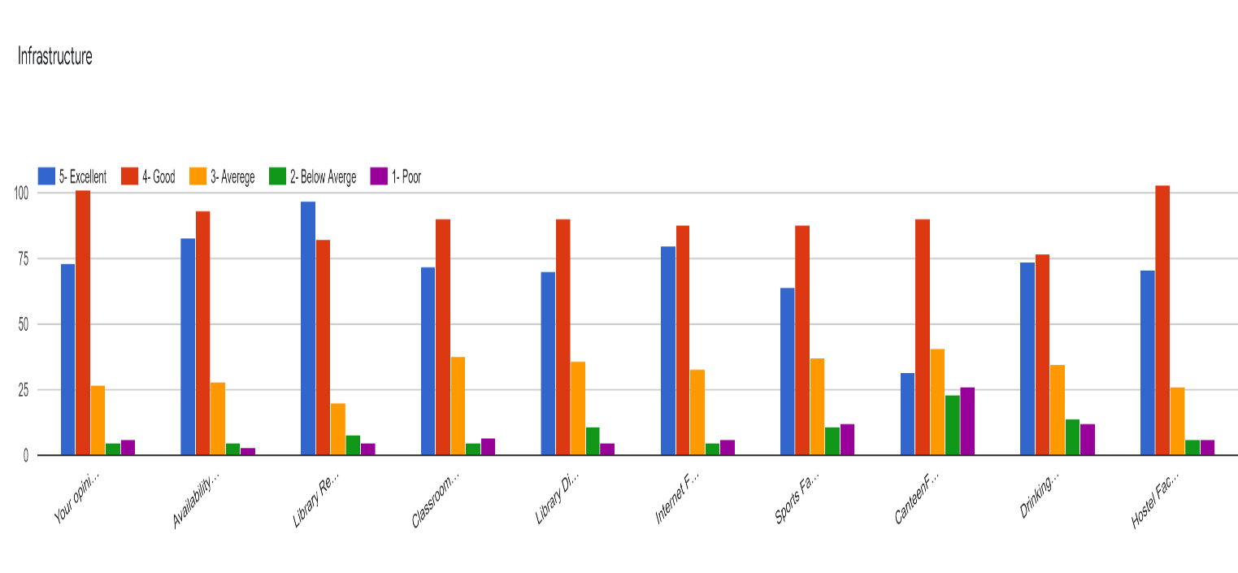

1. opinion about the condition of Lab Equipment’s in the college

2. Availability of Online Resources

3. Library Reading Room Facility

4. Classroom Facilities (LCD/Audio/Computer/Seating Arrangement Etc.)

5. Library Digital Resources and Reading Material Support

6. Internet Facility

7. Sports facility

8. Canteen Facility

9. Drinking Water Facility and Washroom Facilities

10. Hostel facility

**13. Tools and systems used in online classes were easy to use and accessible for all.**

**14.  Online lectures were structured and well organized**

15.  Learning materials supplied by the teachers to supplement the online classes were easily accessible

16. There is ample scope for participation and interaction through online learning

**17. Your overall experience or perceived effectiveness of online classes compared to in-class learning.**

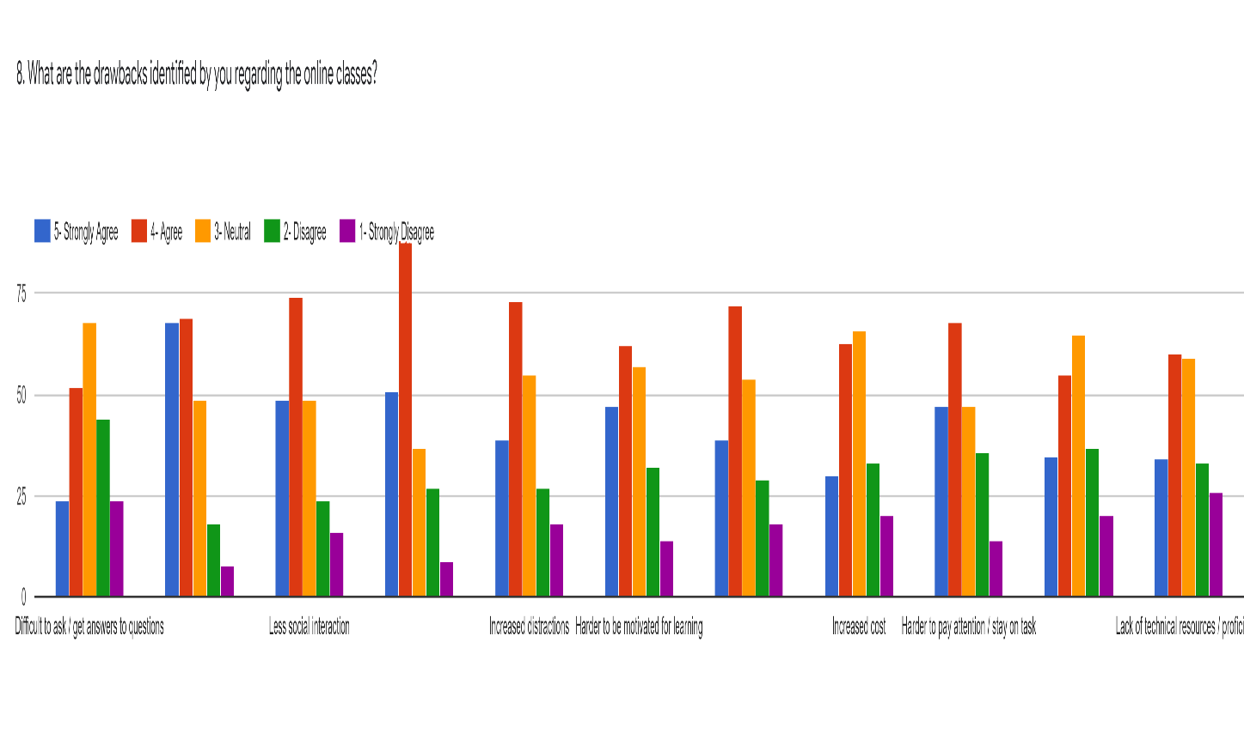18. What are the drawbacks identified by you regarding the online classes?

Drawbacks in online class

1. Difficult to ask / get answers to questions

2. Technical issues with connectivity

3. Less social interaction

4. Requires internet access and devices

5. Increased distractions

6. Harder to be motivated for learning

7. Less hands-on experience

8. Increased cost

9. Harder to pay attention / stay on task

10. Harder to retain information

11. Lack of technical resources / proficiency

**Feedback report**

The various charts and graphs show the different views expressed by the students in regard to their perception of curriculum, teaching learning process, infrastructure, online classes etc. The students’ feedback shows that the curriculum delivery and the teaching learning process was good but the ICT facilities and the library facilities needs improvement. The students are very much satisfied about the infrastructure and academic environment existing in the college and there is suggestion for the improvement of the sports facilities and also the internet facility of the college have to be strengthened. Students are satisfied with the effectiveness of the online classes conducted in the college but they are of the opinion that the offline classes are much more effective than the online classes. The major problems confronted by the students regarding the online classes are technical issues with connectivity, lack of gadgets, less hands-on experience etc.

**Action Taken Report**

1. Decided to conduct more orientation and awareness class to the students.

2. Decided to take necessary steps for the completion of the digital library block.

3. Decided to give proposals for the strengthening of the ICT facilities

4. mobile gadgets were given to the needy students with the support of the Alumni and Teachers.

5. Decided to give more concentration to remedial classes.