Parents Feedback Report 2020-2021

We are collecting feedback from our parents on regular basis. We have designed a special form (online) for collecting the feedback and the same is available on the college website and also on the students’ WhatsApp groups. We are collecting feedback from parents on teaching -learning process/Discipline/online classes/ Infrastructure/ Student support/ teacher student relationship, teacher parent relationship, Administration and co-curricular activities. Parents’ feedback is an important source of information for betterment and development of the institution.

**1. Discipline**

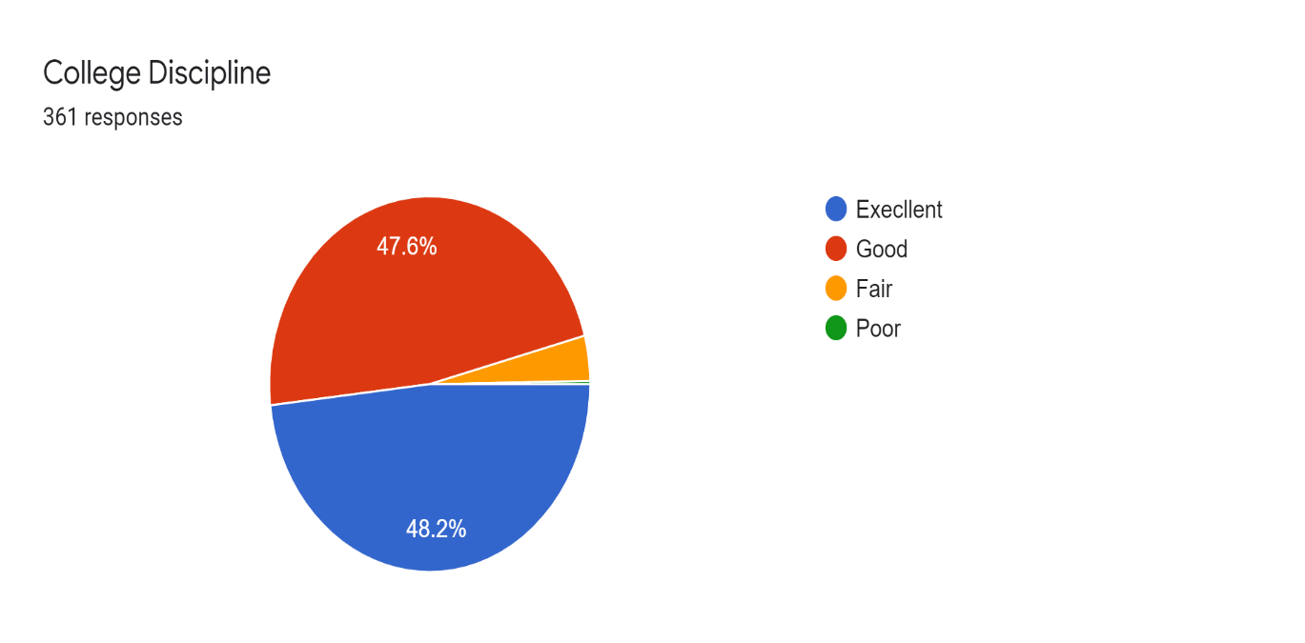

**2. Teacher – student Relationship**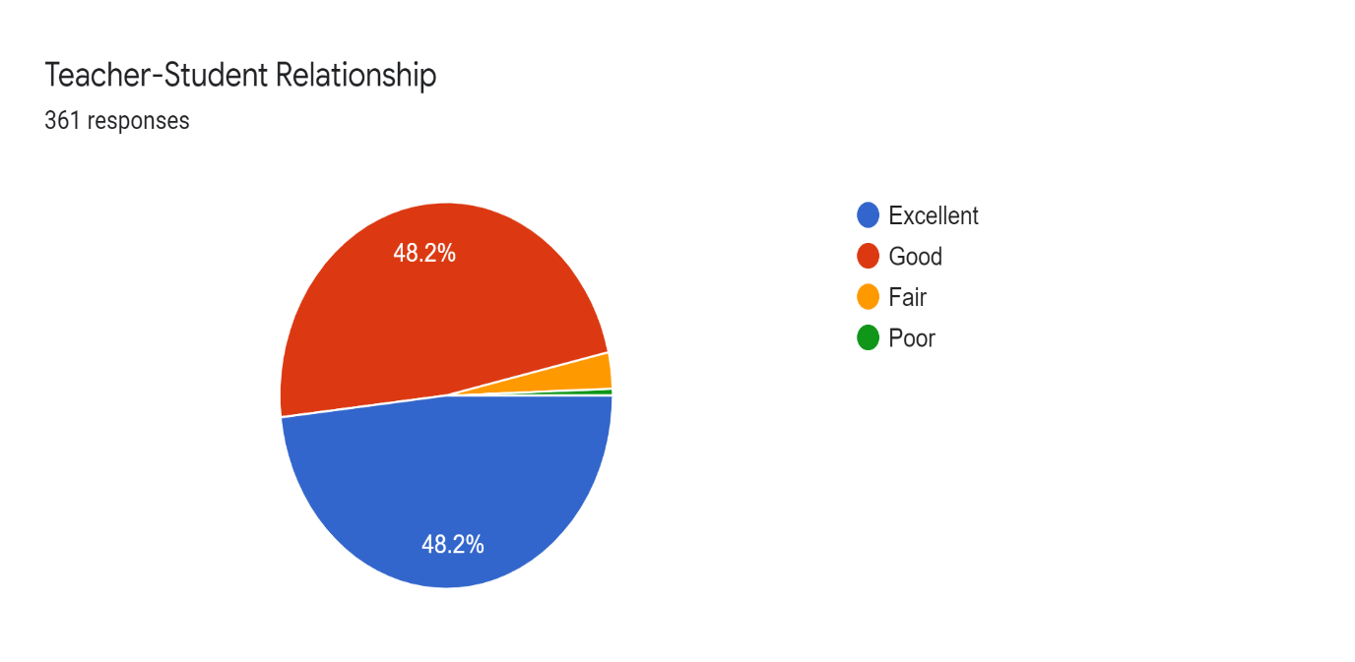

**3. Teacher- parent relationships**

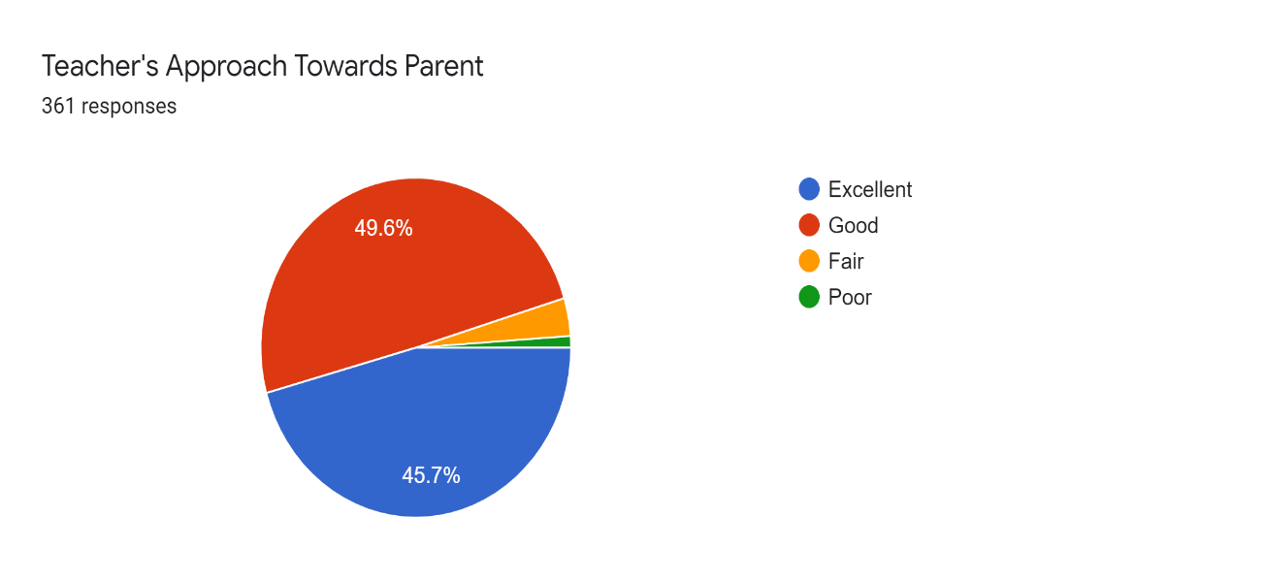

**4. Support for Character building**

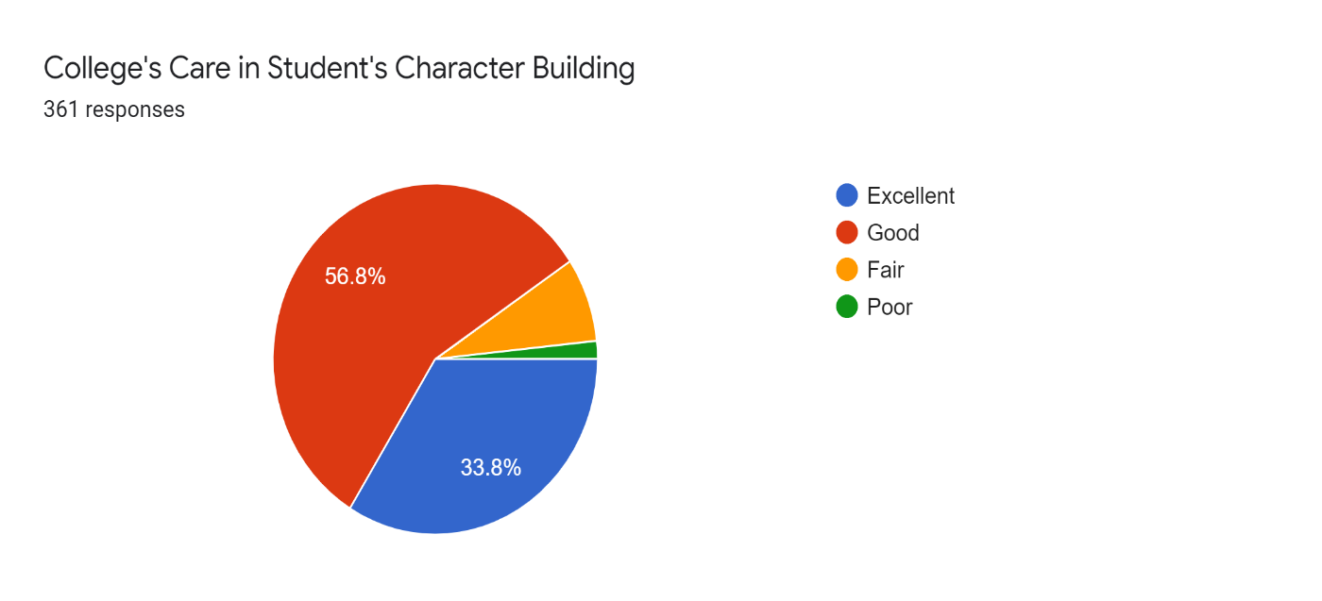

**5. Individual attention**

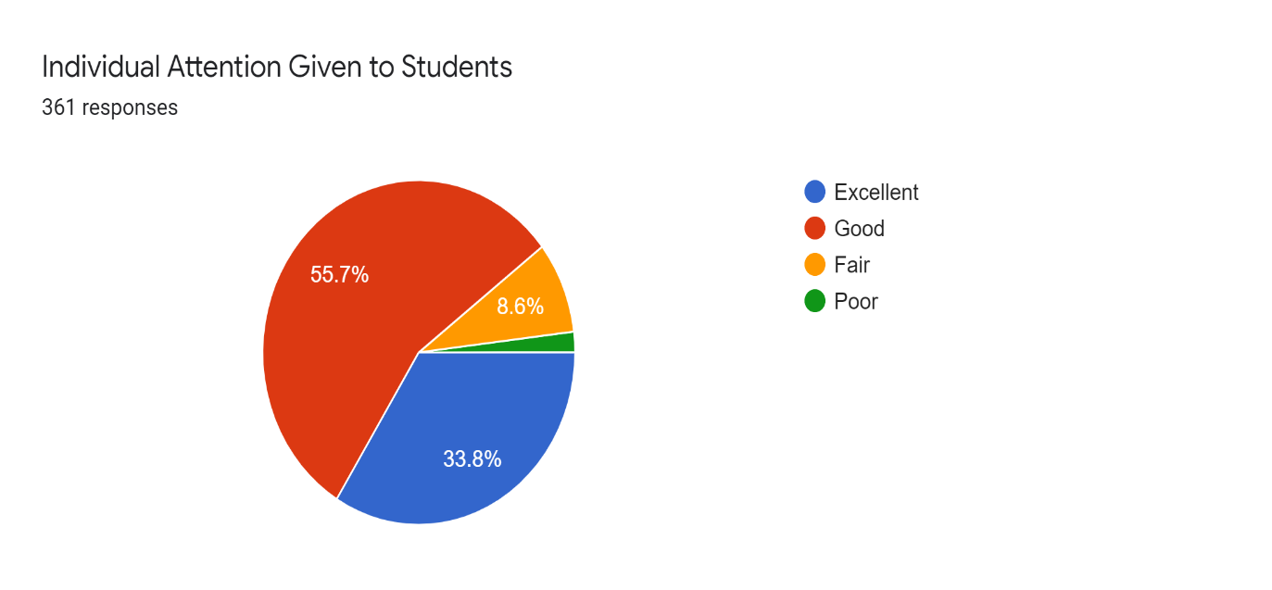

**6. Clarification of Doubts**

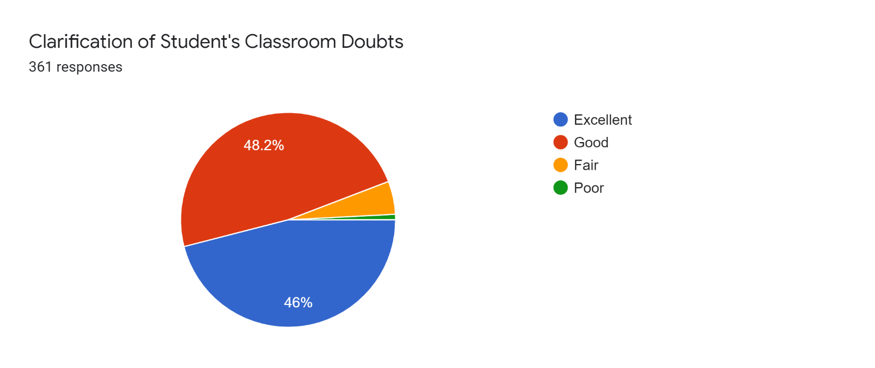

**7. Teaching methods**

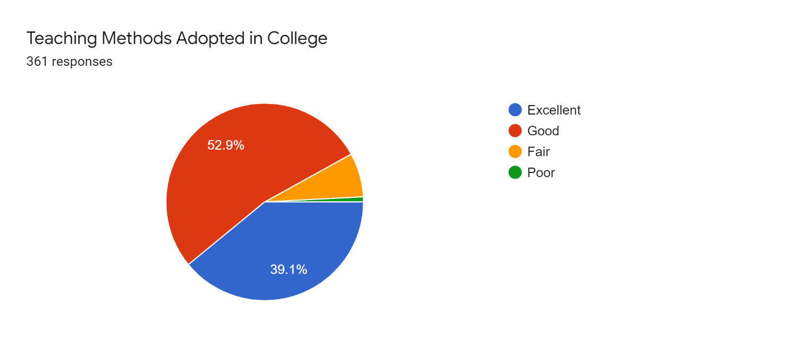

**8. Continuous Evaluation**

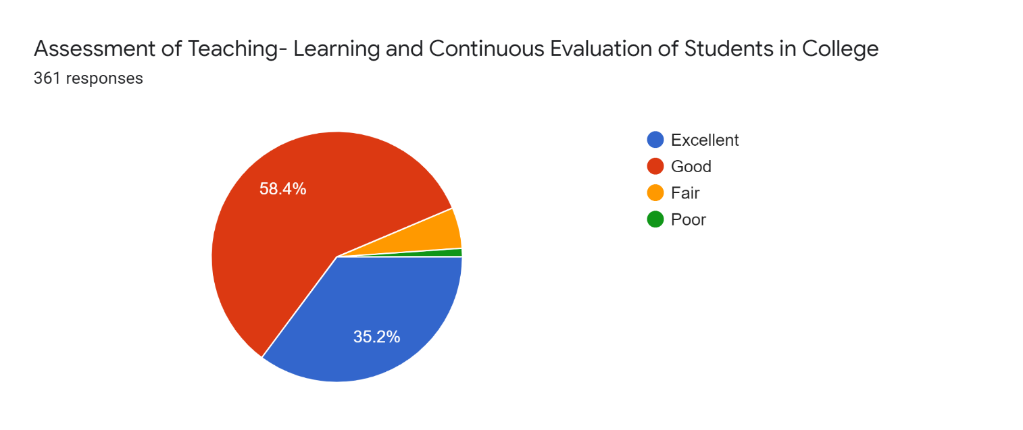

**9. Co- curricular and Extra – Curricular activities**

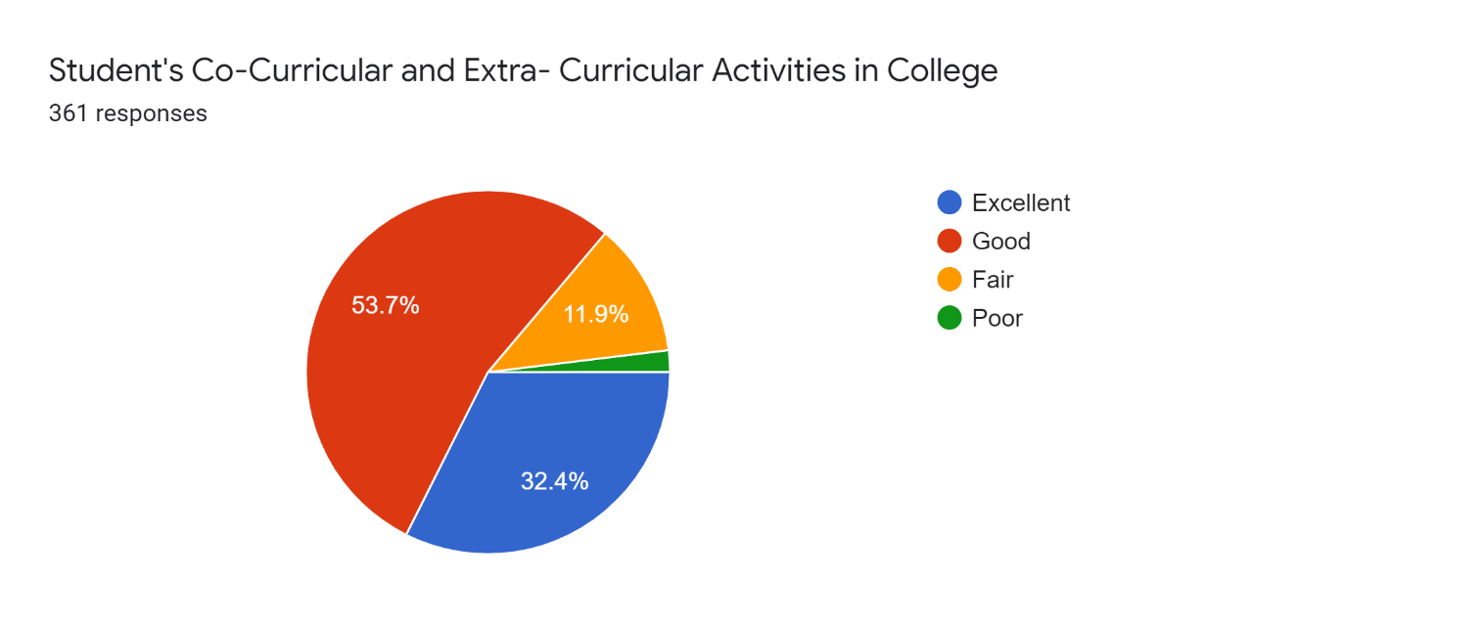

**10. Personality development Programmes**

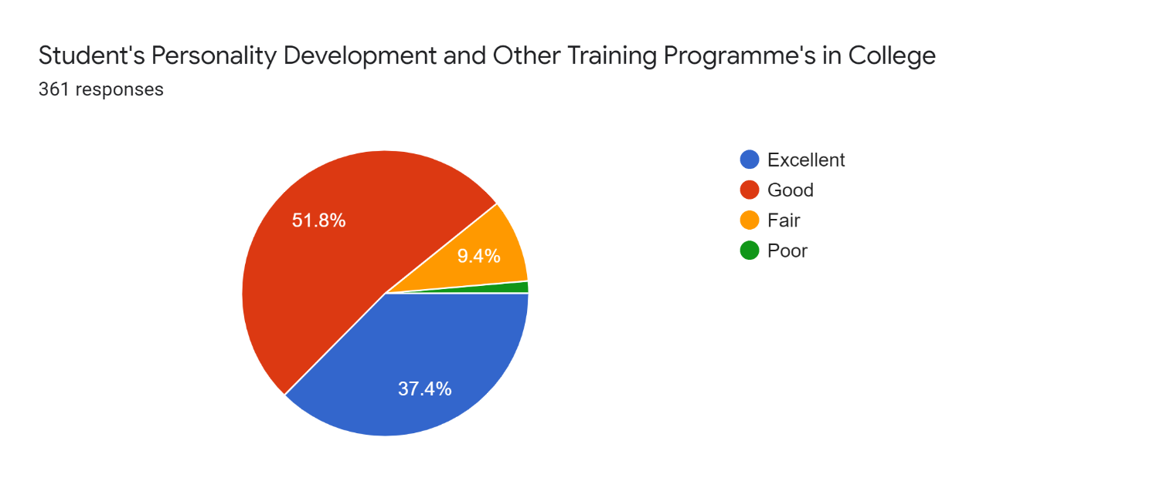

**11. Administration**

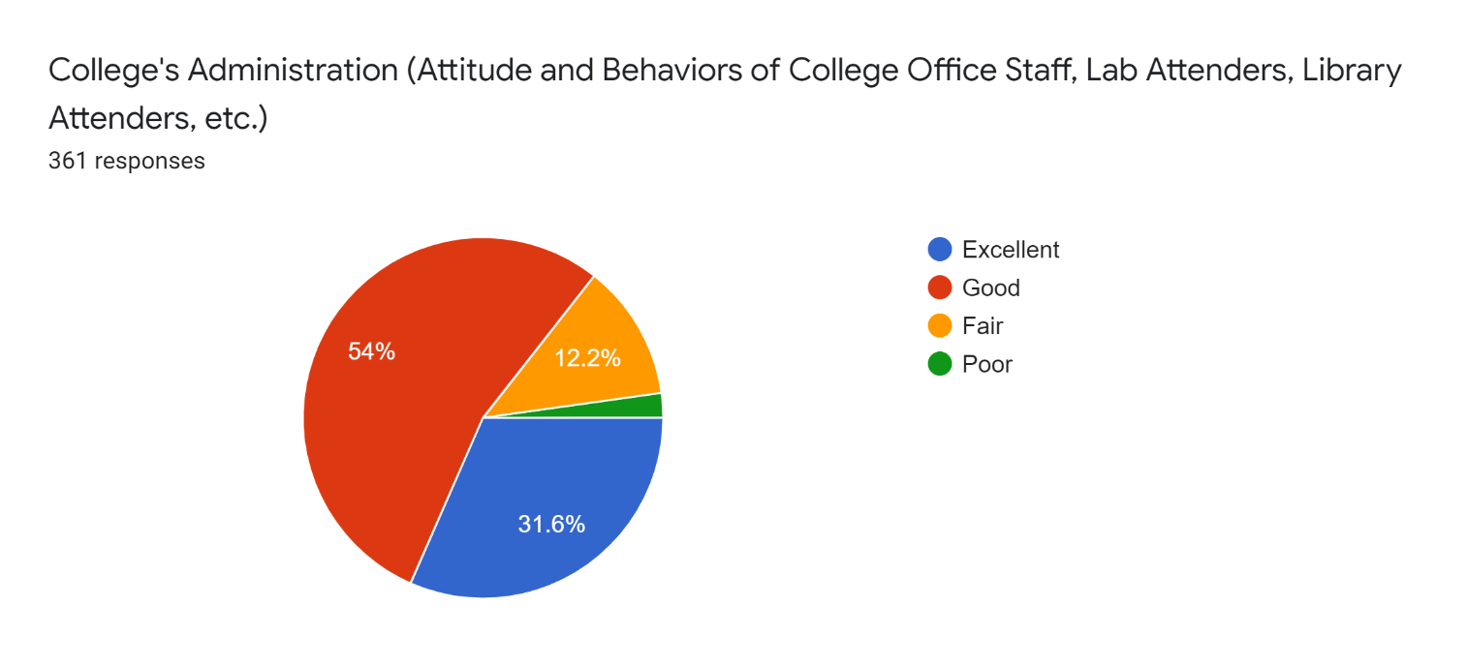

**12. Infrastructure facilities**

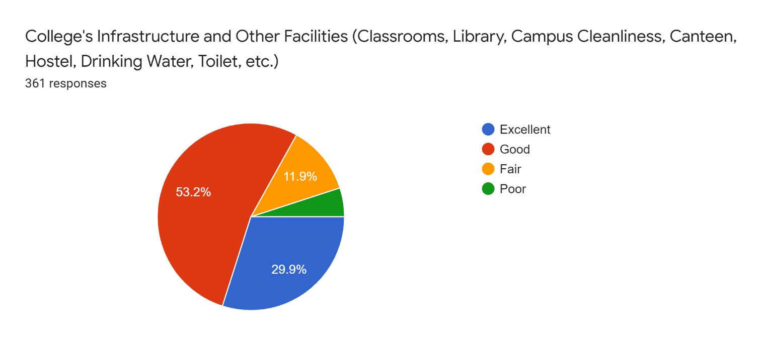

**13. Support to face challenges**

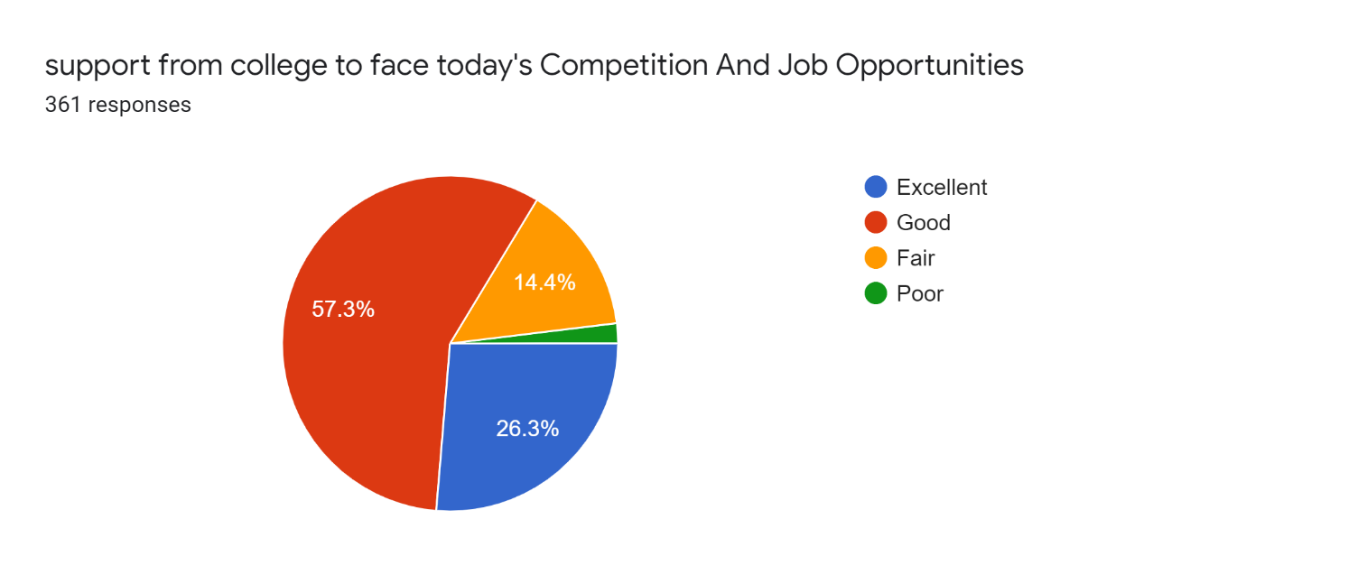

**14. Rating of teachers**

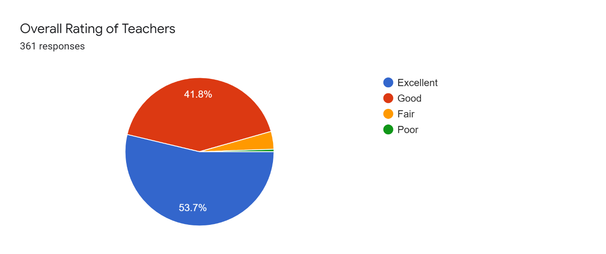

**15. Rating on college**

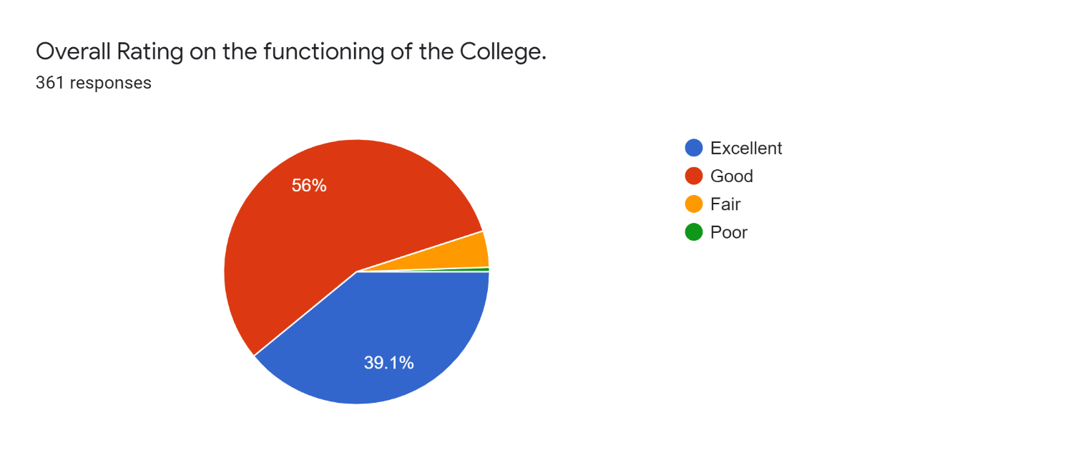

**16. Recommendation of the college to others**

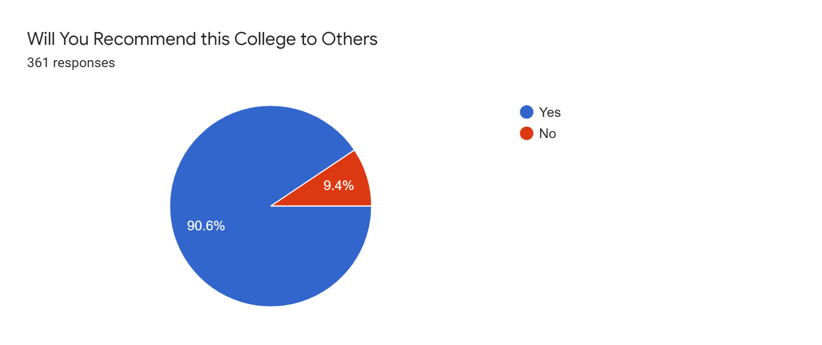

**Feedback report**

The various charts and graphs show the different views expressed by the parents with regard to their perception on teaching -learning process/Discipline/online classes/ Infrastructure/ Student support/ teacher student relationship, teacher parent relationship, Administration and co-curricular activities. The parents’ feedback shows that the teaching learning process existing in the college is good but the ICT facilities and the library facilities needs improvement. The parents are very much satisfied about the infrastructure and academic environment existing in the college and there is suggestion for the improvement of the sports facilities and also the internet facility of the college have to be strengthened. A warm relationship is maintained between teachers and students and between teachers and parents. Parents are very much satisfied with the discipline and training programmes conducted in the college.

**Suggestions**

1.More courses may be introduced in coming years.

2. More improvement should be made in extracurricular activities, especially in sports.

3.More Smart class have to be introduced in coming years.

4. Pg course should be brought in the history department

5. Library facilities should be improved.

6. More importance have to be given to career guidance.

7. Canteen facility should be improved

**Action Taken Report**

1. Decided to conduct more orientation and awareness class to students

2. Decided to take necessary steps for the completion of the digital library block.

3. Decided to give proposals for the strengthening of the ICT facilities.

4. Decided to conduct more orientation and awareness class (Placement oriented) to the students.

5. Applied for new courses and awaiting sanction from Govt. Of Kerala.

6. Decided to give more support to sports and extracurricular activities once the pandemic situation subsides.